**Chapter 1**

**Introduction**

* 1. **Overview**

Pharmaceutical drug has been widely prescribed by physicians in providing appropriate chemical composition to the patients for remedial action. Every drug name is being referenced by multiple brand names in the pharmaceutical industry for marketing the same drug with different brand names to elevate a product. This overwhelming competition across the globe for each brand name provoke the doctors, pharmacist, vendors and medical representatives to be familiar with brand names of the same drug as a ready reckoned. So, in order to tackle this problem, we are going to make application on three different platforms using IONIC Framework.

* 1. **Problem Statement**

Doctors during their practice write brand drugs, which are available in only in specific location and these medicines can’t be purchased from any other geographical area because they are not been sold uniformly across all places.

* 1. **Objective**
* Finds the brand drug in different regions (States).
* Matches the alternative drug consistently.
* Search the nearby region for the availability of required drug through the Drug Name provided by the user.
* Find the exact same content medicine with Different name.

**Chapter 2**

**2.0 Literature Survey**

* 1 mg is an e-commerce health care company based in Gurgaon, Haryana, India. The company was founded in 2012 as Health-kart Plus, a subsidiary of Health Kart, by Prashant Tandon, Sameer Maheshwari, Gaurav Agarwal and Vikas Chauhan. In April 2015, Health-kart Plus spun off into a separate entity and rebranded itself as 1 mg. 1 mg operates an online marketplace for medicines, besides facilitating medical appointments and diagnostic test bookings.
* India's best online pharmacy with a wide range of prescription and OTC medicines are sold out at or viewed on 1MG Application. Use of generic medicines has been increasing in recent years, primarily as a cost saving measure in healthcare provision. There is existing 1MG application which provides the details for Medicine but, did not tell that in which reason this Medicine is going to available so, in our Application we are going to overcome that Disadvantage to provide the Consistency to the User or Caretaker**.**
* Make healthcare accessible, understandable and affordable for a billion Indians.
* Enable consumers to learn more about their medicines and also find more cost-effective substitutes.
* Bring transparency and price-effectiveness to diagnostic tests.
* Revolutionize how a consumer finds the right healthcare professional for his needs.

**Chapter 3**

**3.0 Work Done**

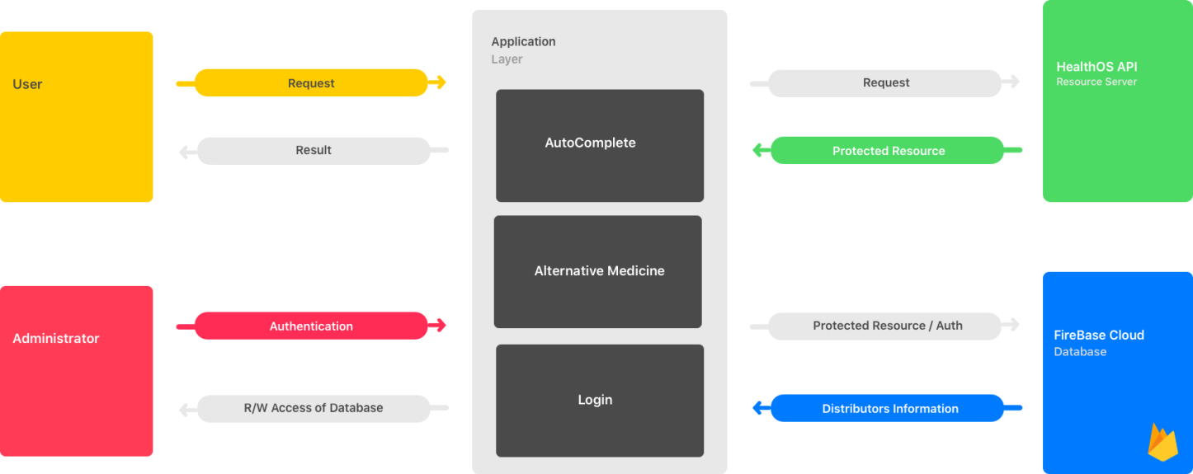

**Fig 1.0 - System Architecture**

**3.1 System Architecture**

* Firstly, the user selects the state in which he/she wants to find alternative medicine and get transferred to the auto complete module. The auto complete module sends the request to the health OS API and gets the response of the medicine names as per user input. After that when the user selects a one of the medicine from the auto complete module response get transferred to the alternative module. In the alternative module, we find the alternative for medicine which user has chosen in the auto complete module by sending a request again to health OS API. This generates the response of the alternative medicine if available.

* A generated response of the alternative module is then mapped to the firebase cloud database accordingly to the distributers available in the state.
* Finally, the output after mapping points to the desired result of the user.

**3.2 Module Description**

* We have used IONIC framework which provides the platform to build an application on one time and use it on Different Platform like Android, IOS, Windows phone which uses Apache Cordova (Compiler) to execute same code on different platform.
* Basically, Cordova Compiler uses Angular-JS language, as well as SASS (Extended Version of CSS) to build an Application.
* So, by using IONIC Frame work we have completed our work and make 1Application on 3 Different Platforms.

**Chapter 4**

**4.0 Result and Discussions**

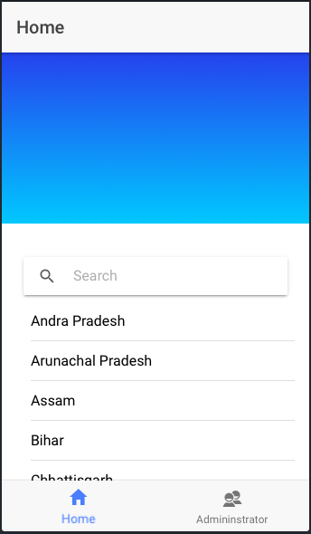

**Fig 2.1: Home Page / Select State**

* One First Home page or Our First module we have given a search box for selecting the state of the user currently available.
* You can search all over the 29 States present in India or Select it from the List area.
* The selected state is Stored inside the object in type Script (language developed by Microsoft) and through to the next module for further process.

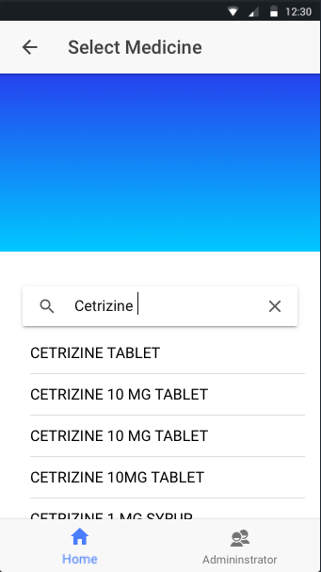

**Fig 2.2: Select Medicine**

* In the Second Module, User can Search the name of medicine he/she want to search.
* Which is further Fetch from our Database to find the Content of that searched medicine.

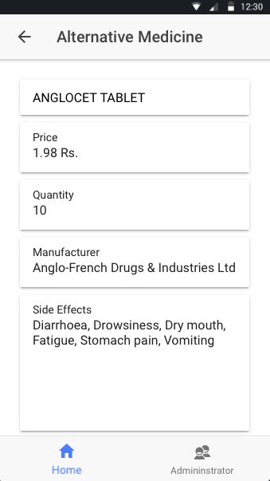

**Fig 2.3: Alternative Medicine Information**

* In our Third module, we are getting the data from health OS API and displaying it to the user with content and description.

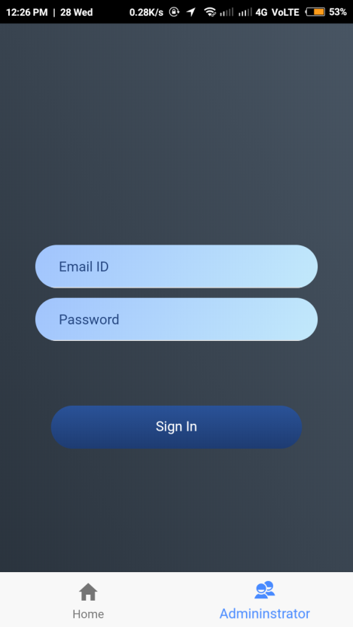

**Fig 2.4: Admin Login**

* In our fourth module, this is our authentication page where only the authorized person has access to our secondary database (Google Firebase) which is going to add or modify in future directly from here.

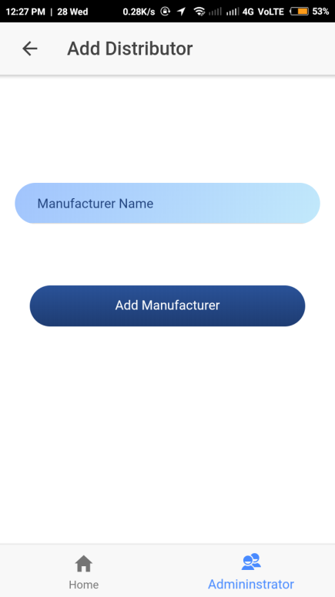

**Fig 2.5: Add Distributer**

* In our Fifth module, we can easily **add** distributer information to our database.

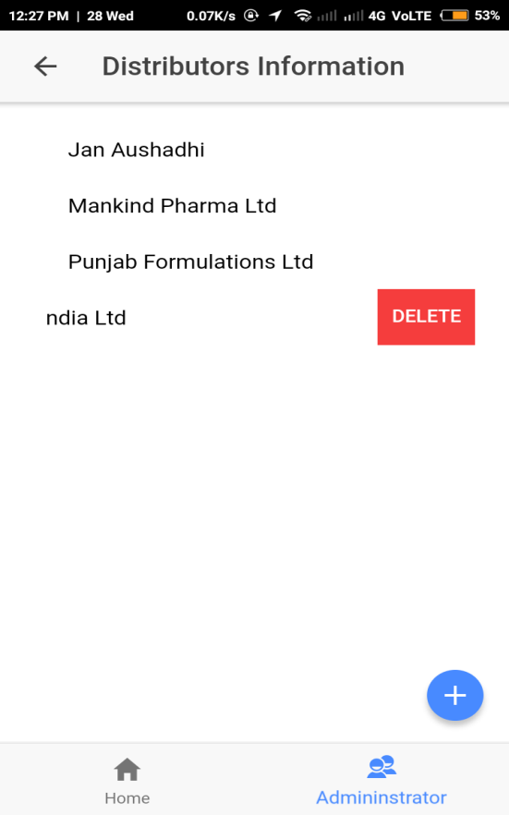

**Fig 2.6: Delete Distributer**

* In our Fifth module, we can easily **delete** distributer information to our database.

**Chapter 5**

1. **Summary and Conclusion**

**5.1 Summary**

.

As, we are building an application which is “Finding Similar Brand Drug in Other Parts of Country” application will find the exact same alternative medicine with the description, price, content and side effects. Every drug name is being referenced by multiple brand names in the pharmaceutical industry for marketing the same drug with different brand names to elevate a product. HealthOS API gives us platform to search 500 requests per day in HealthOS API database where more than 1 Lakh medicines is already available for educational purpose through single user. Administrator will add as well as remove the information of Distributer from our secondary database which is Google Firebase. Thus, this will help for finding the person lives in different regions (States) throughout the country.

**5.2 CONCLUSION**

In this project, we effectively use distributer information to reduce the efficiency of region wise medicine selling with different name. Sorting is done on the basis of distributer information which is in the specific region depending on manufacturing unit (Brand Drug).Similarities of the medicine with the exact same content is mapped by using Auto-Complete module if the medicine with exact same content is present then and then only the alternative medicine is shown otherwise No medicine is found Toast message is generated. In 1MG application everything shown (.i.e. content, price, side effects, and quantity) about medicine but which medicine is generally available in which region is not shown. But, in our application we are going to overcome that problem by use of adding Distributer Information in our Secondary Database (Google Firebase) while mapping it with medicine similar drug is find and shown it to the Caretaker or Customer. Hence, we have successfully implemented our project to overcome the problem of region wise (State wise) medicine availability or Selling.

**5.3 Future work**

For a Future work we can add the G-maps in our Application to make it more Convenient to use and find the alternative medicine directly on Maps from our nearest location to the shop. As, we are getting the Drug information from health OSAPI in future by Contributing the ID's of User to that Site. We can take Advantage of Searching More medicine through One Id i.e. less than or Equal to 500

**Chapter 6**

**6.0 References**

* Ionic Framework Documentation <https://ionicframework.com/docs/>
* Firebase (Authentication and Documentation) <https://firebase.google.com/docs/>
* HealthOS API documentation <https://documenter.getpostman.com/view/264>